HOLIDAY PRORATION GUIDELINES FOR PART‐TIME EMPLOYEES

Part‐time benefited employees receive pro‐rated holiday time based on the number of hours they work each week. The number of prorated holiday hours is equal to an employee’s weekly scheduled hours divided by 5 (days). See the table below for examples:

Scheduled Work Hours | Holiday Proration Entitled | FTE
36 | 7.20 | 0.90
35 | 7.00 | 0.875
34 | 6.80 | 0.85
32 | 6.40 | 0.80
30 | 6.00 | 0.75
28 | 5.60 | 0.70
25 | 5.00 | 0.625
24 | 4.80 | 0.60
20 | 4.00 | 0.50

Part‐time employees may need to report time in HR/Direct on University holidays. Please see the three scenarios below for HR/Direct Time Reporting instructions.

Holiday falls on an employee’s scheduled workday but scheduled hours are GREATER than the prorated holiday hours.

For Example: Employee works 24 hours per week, entitled holiday hours = 4.80, but employee’s regularly scheduled work hours is 8.

Employee takes the Holiday off

Action Required: Employee must report the appropriate number of HOL hours as well as leave time (VAC/PER/HCTU or NOP) to make up the difference between their scheduled hours and their prorated holiday hours.

Manual time entry should be 4.8 hours HOL and 3.2 hours of VAC/PER/HCTU or NOP to = 8 hours

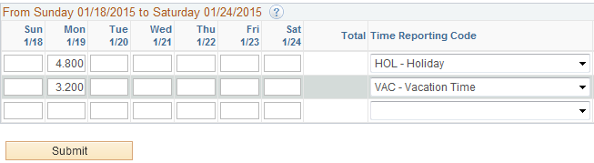

Employee works on the Holiday (scheduled hours GREATER than prorated holiday hours).

For Example: Employee is requested to work 8 hours on the Holiday by manager.

Action Required:

Step 1: Report the number of hours worked, then selects the Time Reporting Code “HCTES – Holiday Comp Time Earned Straight”.

Step 2: Employee must also report the appropriate number of HOL hours as well as leave time (VAC/PER/HCTU or NOP) to make up the difference between their scheduled hours and their prorated holiday hours.

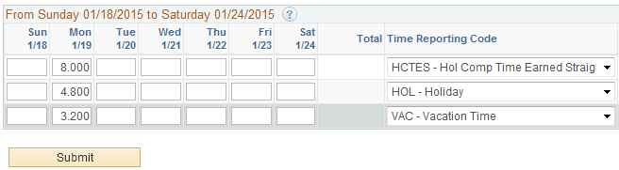

Holiday falls on an employee’s scheduled workday and scheduled hours are EQUAL TO OR LESS THAN the prorated holiday hours.

Employee takes the Holiday off

NO Action Required: No time reporting is required. System will create both prorated holiday hours (HOL) and, if necessary, holiday comp time (HCTES). Reminder ‐ Holiday comp time must be used within 120 days.

Employee works on the Holiday

For Example: Employee is requested to work on the Holiday by manager.

Action Required: Report the number of hours worked up to your scheduled day, then select the Time Reporting Code “HCTES – Holiday Comp Time Earned Straight”. You also need to report the number of hours you would earn as your holiday benefit. For this example, we assume you are scheduled for 4 hours and that is your prorated amount to earn.

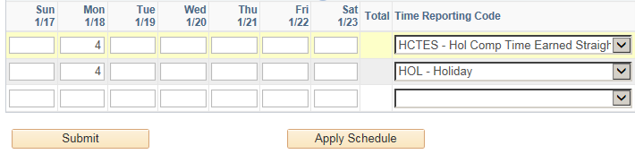

Holiday falls on an employee’s regularly scheduled day off.

No Action Required: No time reporting is required. System will create Holiday Comp Time (HCTES) hours entitled per chart above.

Reminder ‐ Holiday comp time must be used within 120 days.

Please contact Human Resources if you have any questions:

Human Resources Main Line 774-455-7150 | Sharon Vieira 774‐455‐7566
Jacqui Kittler 774-455-7559 | Carol Dugard 774‐455‐7572

